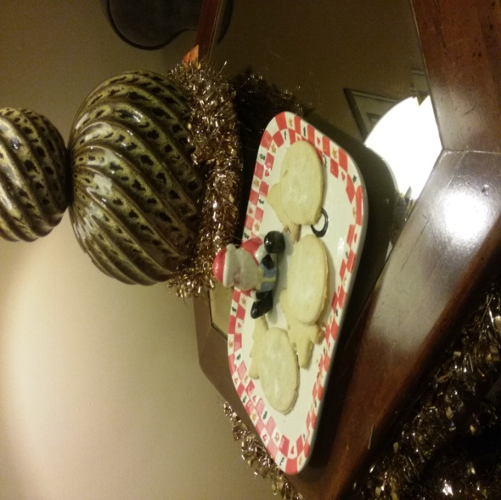
Classic Sugar Cookies
1 cup Sugar
¾ cup Butter, softened
½ teaspoon Salt
1 Egg
1 teaspoon Vanilla Extract
1 teaspoon Lemon Zest
2 ¼ cups Flour
1 teaspoon Baking Powder
Additional sugar

Directions: Preheat oven to 350 degrees. In a large bowl, mix sugar, butter, and salt. Afterwards, beat in the egg, lemon zest, and vanilla until light and fluffy. In another bowl, sift together flour and baking powder. Gradually stir flour into the first sugar and butter mixture.
On floured board, using a floured rolling pin, roll dough until 1/8-inch thick. Cut into whatever holiday shapes you would like!
Place on an ungreased baking sheet and bake for 9-12 minutes or until lightly browned around the edges.

